COVER SHEET

Student Name: | Shermukhammad Nomanov | Module Name: | Object Oriented Programming with C++
Student ID: | TM223-0817 | Module Code: | COS212
Assessment Type: | Individual | Learning Outcomes Assessed:
Deadline: | 7.05.2026 | Date of Submission: | 7.05.2026
Institution: | TMC Institute in Tashkent

Signature of Assessor: | Signature of Moderator: |  | Overall, Mark (subject to ratification by exam board)
This work is fully done by me and I referenced all the sources I used in this work.
Student signature: |  | Shermukhammad Nomanov Nodirjon o’g’li

Table of content
Introduction 3
Objectives 3
Main menu 4
Admin panel 5
Student Module 6
Teachers/Employees Module 7
Menu options in Student Dashboard 8
Bye animation 8
Backend 9
Structs 9
University.cpp 10
Main.cpp 11
Boxes 12
Exception handling 12
Methods 13
Database 15
University.cpp 16
Methods 17
Conclusion 19
Reference list 20

Introduction
The project and report are done by Shermukhammad Nomanov TM223-0817.
The project presents a console app made in Visual Studio using C++. The console app presents a university management system designed to efficiently manage personal information of students, teachers and staff.
The project fully follows the requirements given in the assignment instructions.

Objectives
The project strives to achieve several objectives:
- To “create a simple console-based C++ program”
- Making sure the app works smoothly
- Designing a simple and an easy-to-use interface
- Allowing to perform CRUD operations on data
- To store data in a local database
- To implement Object Oriented Programming concepts
- To implement basic Exception Handling

Here is a link to the project:
https://drive.google.com/drive/folders/1yoB7h16fw4bTvNxgYlJsfqCXPPow7Kdv?usp=sharing

Main menu
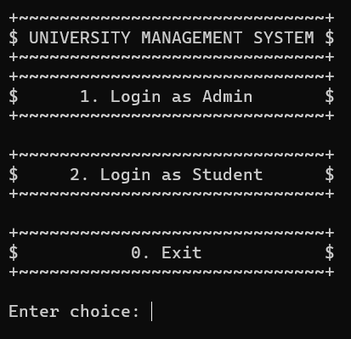
The first page presents a simple main menu giving a user a choice between logging in as an admin, as a student, or exiting. The user needs to insert 1, 2, or 0 to perform a specific action. This decision-making process is achieved by implementing a switch.
As it is shown on the screenshot, each choice including the title is wrapped in a fancy box made of symbols. This was achieved by performing a loop which will be explained later in the report.

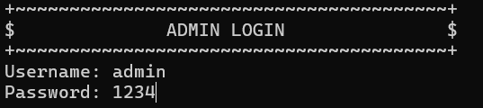
Choosing 1, directs the user to a login page for admins asking for a username and a password. In this project, the username is admin, and the password is 1234.

Admin panel
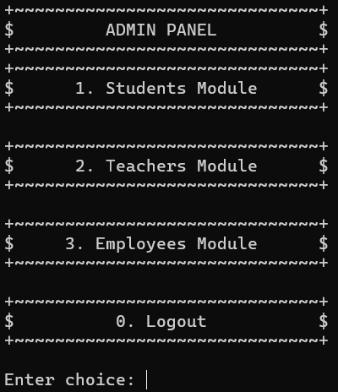

After signing in successfully, an admin dashboard opens three large sections. These sections contain a number of actions that can be performed on Students, Teachers, and Employees.
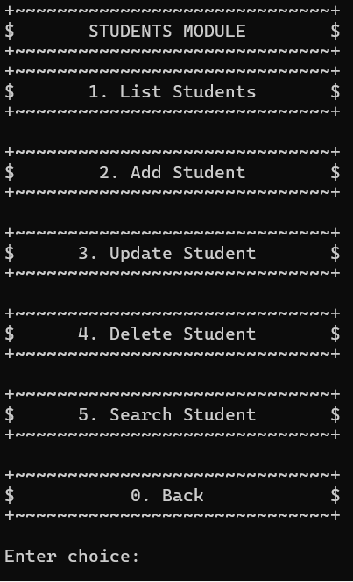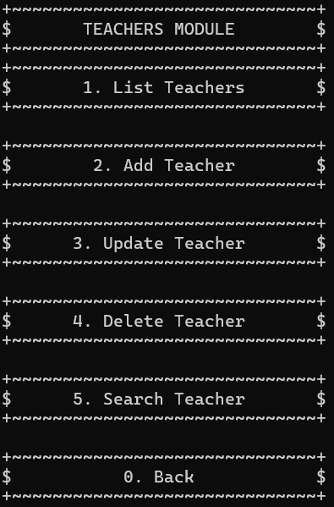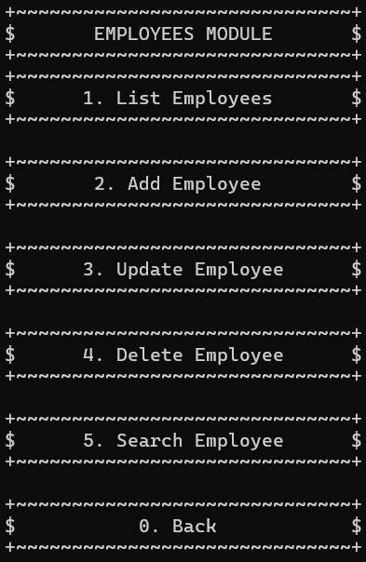


Student Module
Entering Students Module is followed by another panel for performing CRUD operations on students.
Choosing the first option shows a table of current students each of them having a unique ID, a name, marks, and a grade.
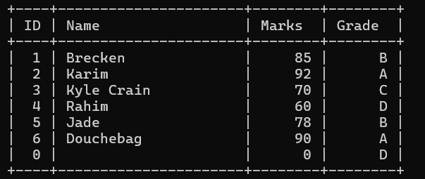
When choosing the second option, program asks for parameters such as ID, name, password, subject count, assignment count and a mark. The inputs require specific format, and if an incorrect format is inputted, the program throws an exception.
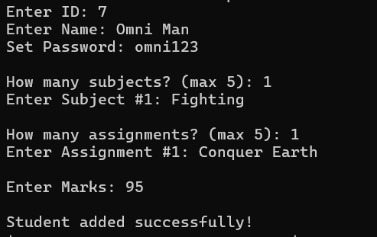

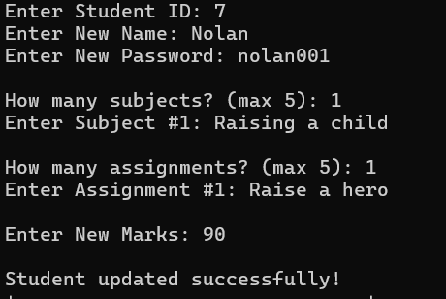
If the admin chooses the third option, the program asks for ID of the student they want to change. If the inputted ID exists, the program continues to ask for a new name, password, and so forth.
Meanwhile, choosing the fourth option will lead to program asking for an ID of the student that is about to be deleted.
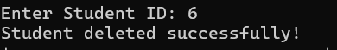

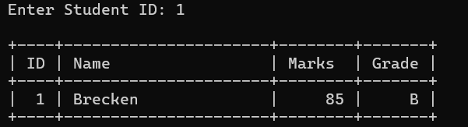
Finally, choosing the last option is for searching a student. The program asks for an ID of the student, which then reveals the student’s personal information.

Teachers/Employees Module
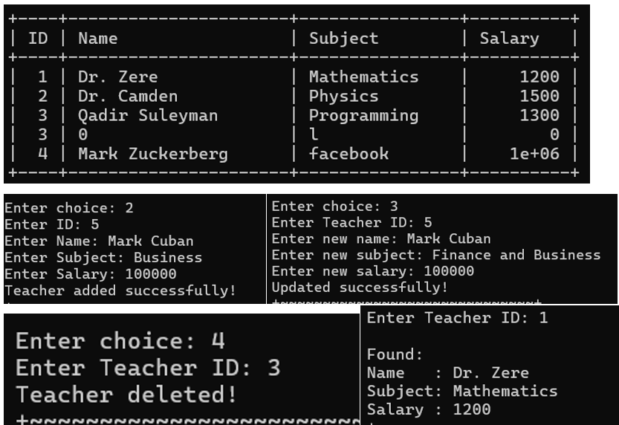
Teacher Module of the admin panel works almost the same way as Student Module except there are a few changes in the fields that the program asks for when adding, or updating a teacher.
Same thing applies to Employee Module.
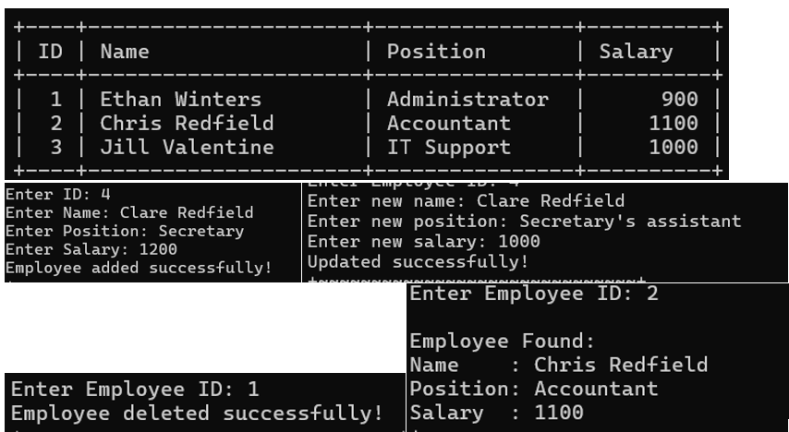

Menu options in Student Dashboard
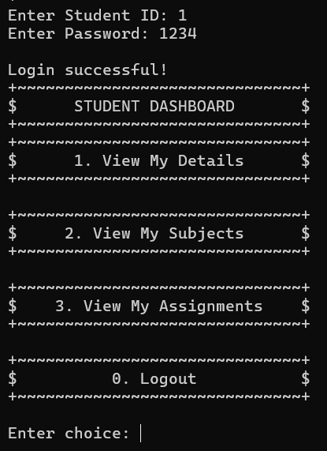
In the main menu, if the second option is chosen, Student login menu opens asking for student ID and password.
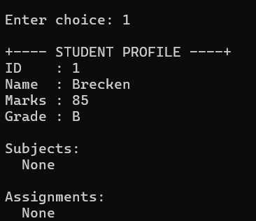
View My Details option shows the profile of the student with his ID, name, marks and grade with subject and assignments below that.
Choosing the second and third options reveals the subjects and assignment a student.
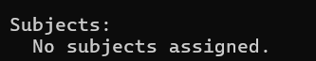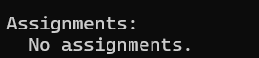

Bye animation
Lastly, choosing the third option in the Main Menu, exits the program. However, the program does not end like other programs. Upon exiting a 3-second animation of a waving stickman saying bye-bye will play.
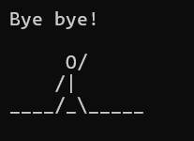

Backend

Structs
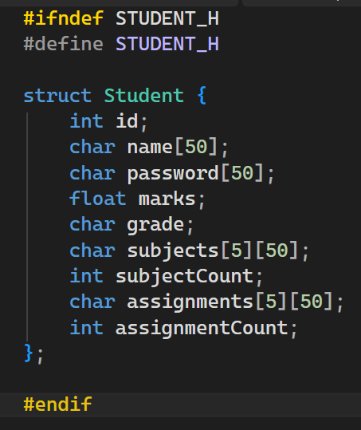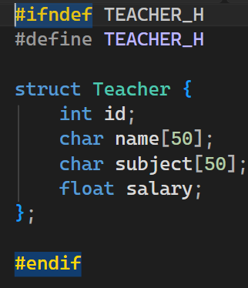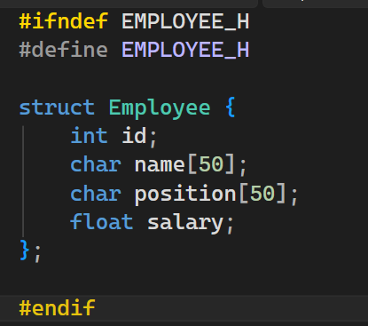
These screenshots illustrate blueprints for students, teachers and employees. The fields that the program asks for when adding a new student/teacher/employee are taken from Student, Teacher, Employee structs from Student.h, Teacher.h and Employee.h files.
Student struct has fields for an ID, a name and a password up to 50 characters, marks, and grades. Following that are subjects and assignments which are limited to the count of 5 and are limited up to 50 characters.
Teacher struct has fields for an ID, name and their subject, both up to 50 characters, ending with a salary.
Employee struct has fields for an ID, name and their position, both up to 50 characters, ending with a salary.

University.cpp
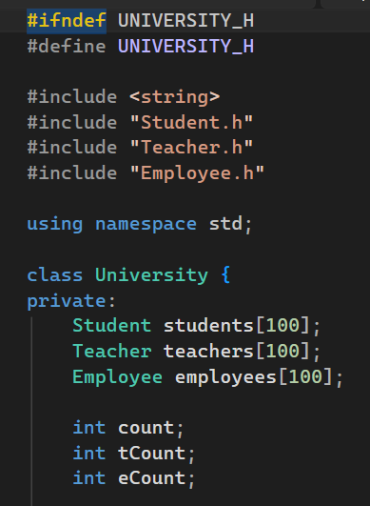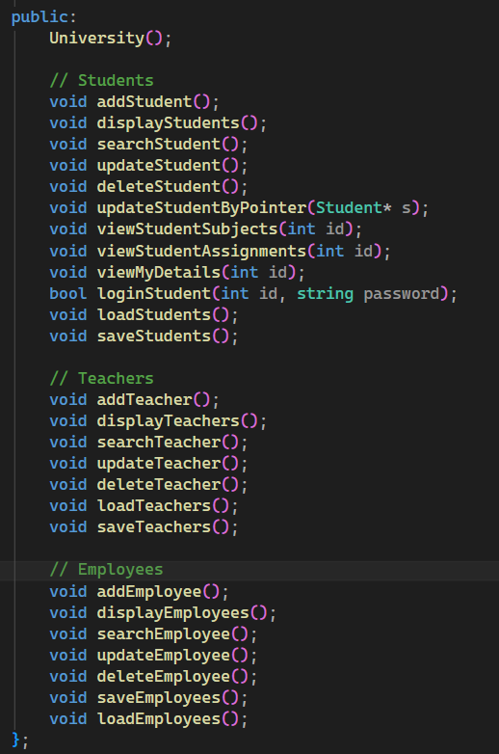
There is also a filed named University.h. This is where all the functions are declared.
The file starts with linking Student.h, Teacher.h and Employee.h. It is followed by creating a class University with private fields: students, teachers and employees with all of them being limited to 100 objects. After that come variables for counting how many objects of those structs there are: count (for students), tCount (for teachers), and eCount (for employees).
After private fields, come a lot of methods that are marked as public. Those methods are for performing CRUD operations on students, teachers and employees that were mentioned earlier in the report.

Main.cpp
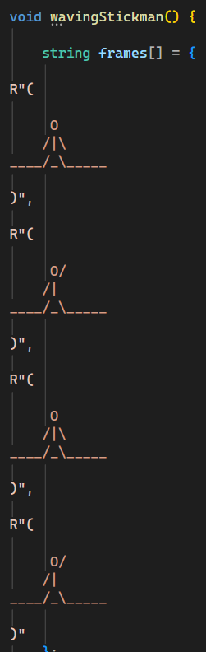
Main.cpp file starts from creating a method called wavingStickman() to create that very bye-animation. It starts with defining frames followed by a for-loop specifying the loop should iterate 12 times. Then it clears the console screen before showing the animation by iterating through 4 frames and plays the animation for 3 seconds.
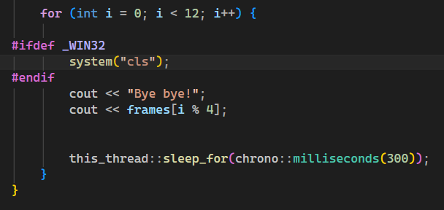

Boxes
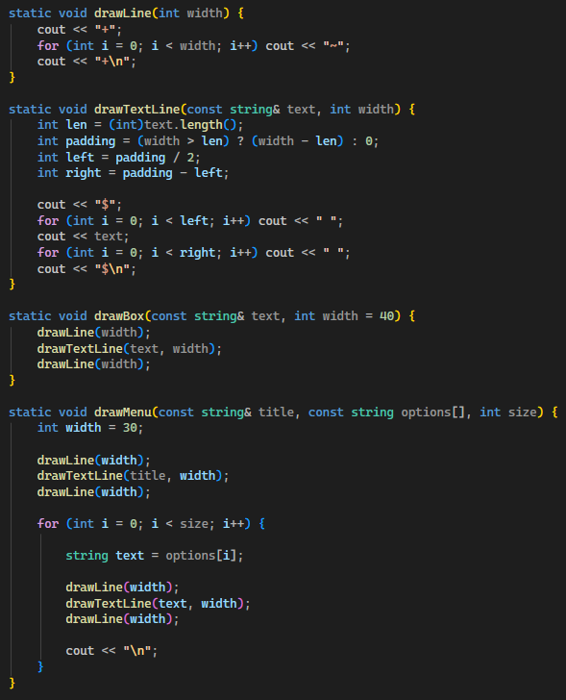
The fancy boxes that wrap panels in the program are created here.
There are four separate methods for creating the boxes.
The first method is drawLine which is responsible for drawing horizontal lines using ~ symbol and putting + symbol for corners.
drawTextLine() method is responsible for printing text inside boxes and keeping them at the center. It calculates the length of text and keeps it centered by adding padding on both sides and puts $ symbol as vertical lines.
drawBox() basically combines the previous two methods and does the actual drawing. It uses drawLine() first to draw a horizontal line at the top, then drawTextLine() to draw vertical lines on the sides and drawLine() again to complete the box with a bottom horizontal line.
Lastly, drawMenu() method is responsible for going through all the menu options and drawing a box around them. To be more specific, while drawBox() method draws a box around the menu itself, drawMenu() draws boxes around menu OPTIONS.

Exception handling
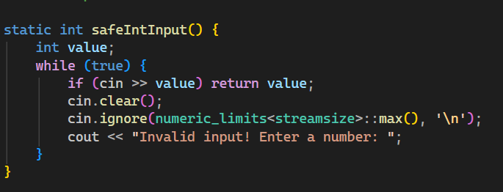
As mentioned above in the report, the program includes basic error handling. To do that, safeIntInput() method was created. It contains an integer value which is put inside a while-loop and is compared to the input. If the input is valid, the loop returns the value. But if not, the condition fails and the following text appears.

Methods
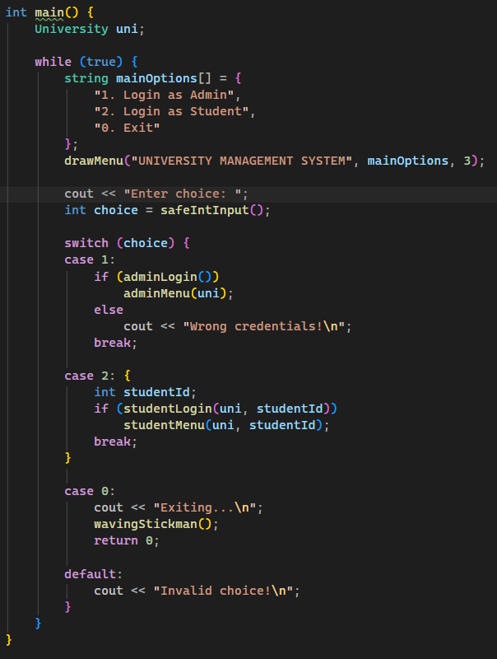
After that comes the main() method. It starts with a while-loop and printing out options for the menu and drawing box around them with exception handling following that.
Next comes a switch, where in case 1 is chosen adminLogin() method runs with adminMenu(), while 2 runs studentLogin() and studentMenu() method and 0 exits the program running wavingStickman() method for the animation. However, if the choice is none of them, the program prints “invalid choice”.

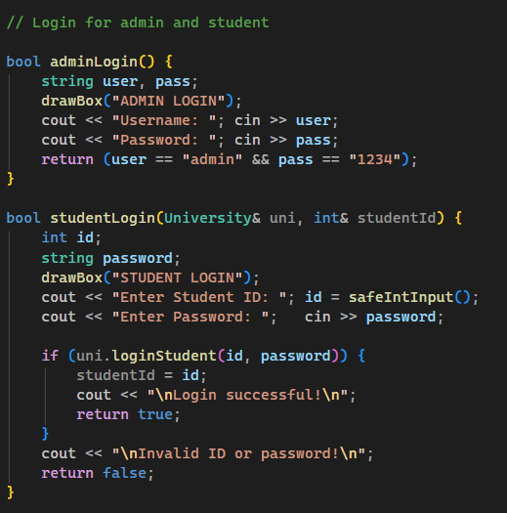
adminLogin() method starts with a drawBox method wrapping “Admin Login” with a box, then printing two inputs for username and password.
Meanwhile, studentLogin() method runs if the user choose 2. It also starts with wrapping the title with a box and asking to input ID and password.
Below what there is decision making section, where if studentID = id that is stored in the database, it logs in successfully. If not, it prints “Invalid ID or password”.

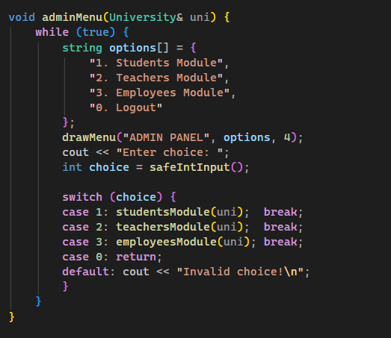
adminMenu() method is responsible for opening an admin panel consisting of options for modules. It starts with a while-loop and declaring the menu options and then wrapping them with boxed via drawMenu() method.
It is then followed by a switch that opens a corresponding module when options from 1 to 3 or 0 are chosen.
Menus for students, teachers, and employees work in the same way.

Database
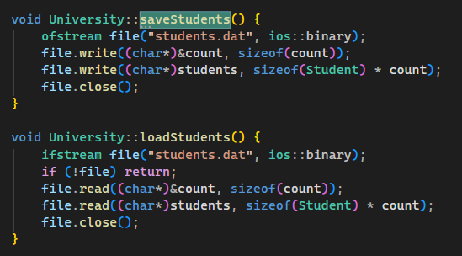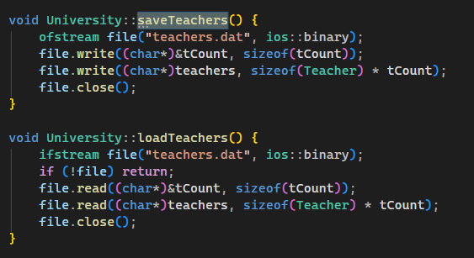
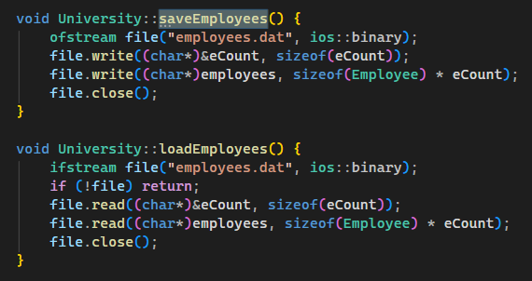
For storage, this project makes use of files with .dat extension. As shown in the screenshots, there are three files created: students.dat, teachers.dat, and employees.dart.
There are two methods for each module, save and load.
Save methods start with ofstream, which is used to write data into these files. Ios::binary means that data will be stores in binary format rather than plain text.
After that the program gets the memory address of count then converts it into char* pointer before writing its bytes into the file.
Next line of code is responsible for saving objects of structs into files after which the file is closed.
Load methods start with getting the saved data from the files before ifstream function is used to read data from files. This is followed by if-statement where it is checked whether the files exist or not. Then file.read() method is run to read the number of objects after which the objects themselves are loaded and the files are closed at the end.

University.cpp
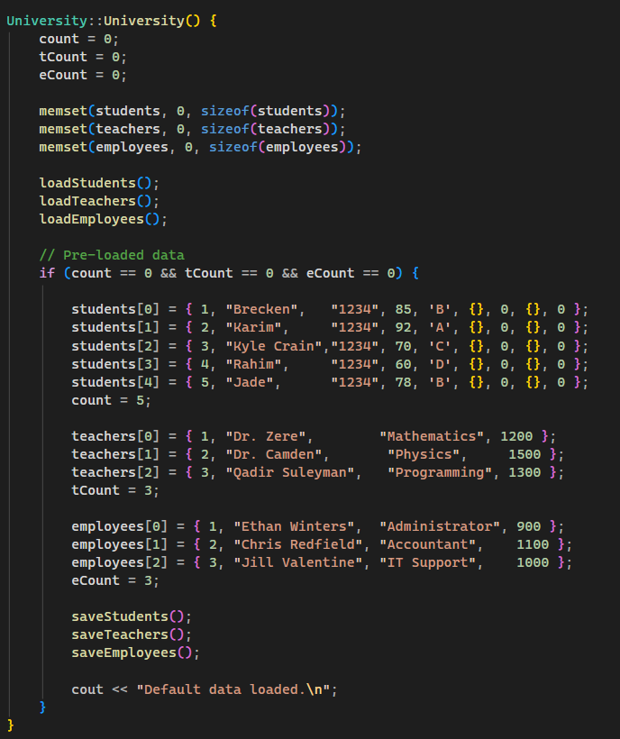
University.cpp is the file where the whole logic for the calculations is made.
It starts with setting counters for students, teachers and employees to 0. Then memset() function is carried out to initialize arrays and set their values to zero.
After that comes a decision making section, where if all the counters are zero, database will be filled with pre-loaded data.
This is for the program to not look empty when it is first launched.
After that, save methods for all three structs is run.

Methods
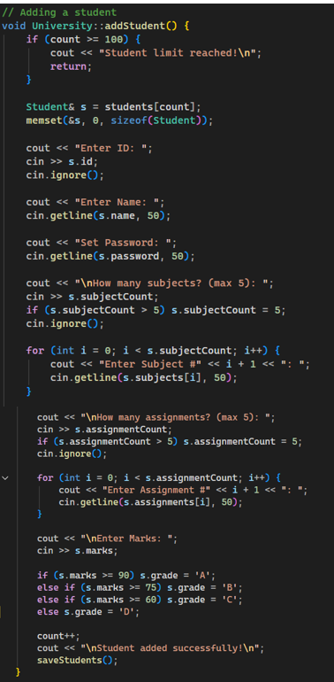
addStudent() method starts with an if-statement, which checks whether the number of students has hit the limit of 100.
After that the method asks for an ID, name, password and the number of subjects and assignments.
The number of subjects and assignments is limited to 5. Therefore, there is an if-statement which checks whether is the number greater than 5.
If the number is or below 5, a for-loop is executed iterating a certain number of times depending on what number was inputted.
The same logic applies for assignments.
Subsequently, the method asks to enter marks which is followed by a switch to figure out what grade a mark is worth. If the mark is or bigger than 90 the grade is A, if it is or bigger than 75, the grade is B, etc.

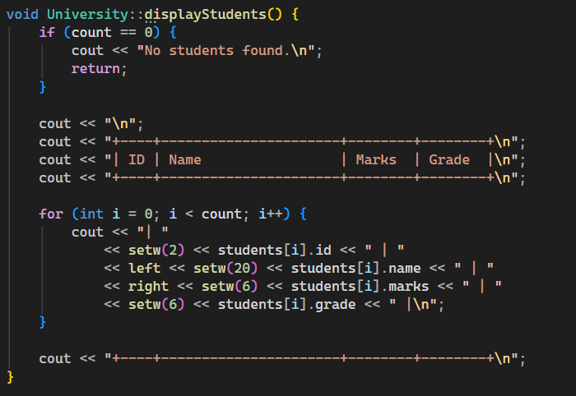
Displaying students functions starts with checking if the number of student is 0. If it is 0, then “No students found” is printed.
If not, a table with columns such as ID, name, marks and grade is drawn.
The table is followed by a for-loop which iterates as many times as the number of students, while putting student’s fields from its Student struct to the corresponding column on the table.

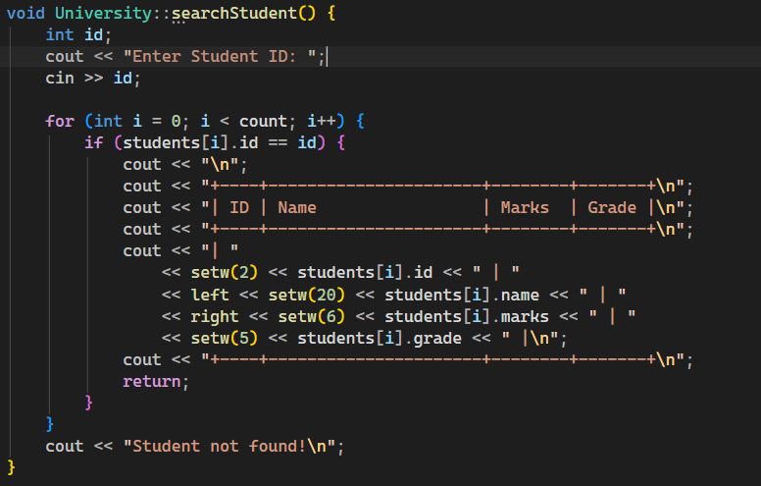
Searching students starts with asking for ID of a student. After that a for-loop starts iterating through all the students to find the matching ID. The if-statement after it checks whether the inputted ID matches with any IDs in the database. If it does a table is drawn with columns and the student’s fields are put to the matching column.
However, if no matching ID is found, the program prints out “Student not found”

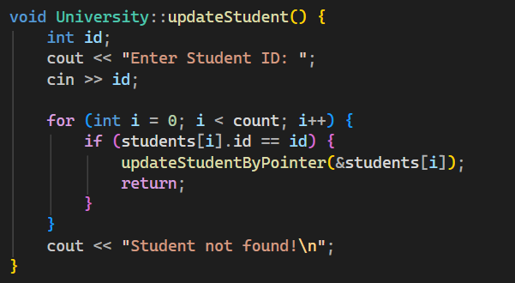

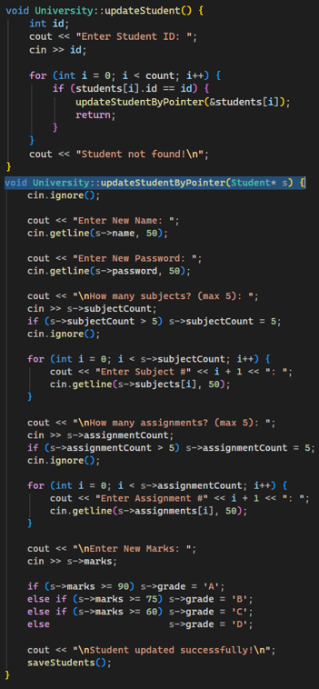
The function of updating a student starts with asking for ID followed by a for-loop cycling through all the students to find a matching one. When found, the id is given to updateStudentByPointer() method.
This method then asks the admin to enter new fields for the student the logic of which works the same way as in adding a new student.
Once everything is done, saveStudents() methods is run to save this change and upload it to students.dat file.

deleteStudent() method starts with asking for ID followed by a for-loop which searches the student with matching ID.
Once found, count—is executed to decrement the number of students by one after which the program prints out “Student deleted successfully”.
At the end, saveStudents() method is run to save the data.
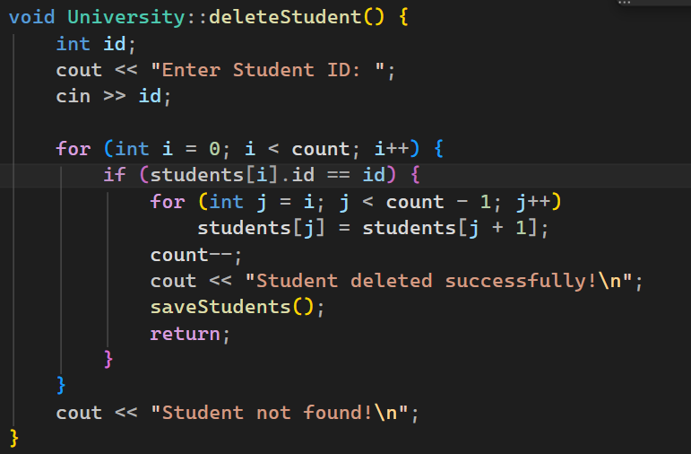
For Teacher and Employee modules methods work the same way and with the same logic, though there are some changes such as field names.

Conclusion
This console app presents a simple university management system that comes with features such as adding, deleting, editing and viewing students, teachers, and employees. The program also comes with a local database based on .dat files and fully follows the requirements given in the instructions.

Reference list
devjeetroy (2011). Simple animation in c++. [online] Stack Overflow. Available at: https://stackoverflow.com/questions/7776776/simple-animation-in-c [Accessed 5 May 2026].
Ehiorobo, E. (2019). Creating a console animation with C++. [online] How-Tos. Available at: https://medium.com/building-a-simple-text-correction-tool/creating-a-console-animation-with-c-18bf9e8ca582 [Accessed 5 May 2026].
GeeksforGeeks (2013). Exception Handling in C++. [online] GeeksforGeeks. Available at: https://www.geeksforgeeks.org/cpp/exception-handling-c/ [Accessed 1 May 2026].
nbaosullivan (2012). Write and read records to .dat file C++. [online] Stack Overflow. Available at: https://stackoverflow.com/questions/10450900/write-and-read-records-to-dat-file-c [Accessed 3 May 2026].
www.w3schools.com. (n.d.). C++ Structures (struct). [online] Available at: https://www.w3schools.com/cpp/cpp_structs.asp [Accessed 1 May 2026].

